Start Script:

Step 1:

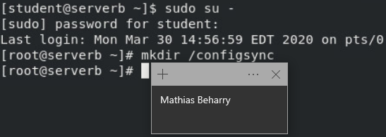

Step 2:

Step 3:

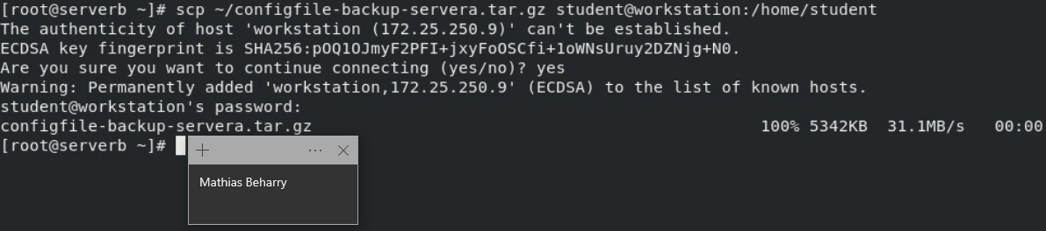

Step 4:

Step 5:

Evaluation Script & Finish Script:

